**Website Project Proposal**

**By**

**Renee Thomas**

**DeVry University**

**CIS363B Web Interface Design w/Lab**

**Week 2**

**Table of Contents**

Website Title 4

Developer’s Name 4

Focus of the Website 4

Mission Statement 4

Intended Audience 4

Web Pages Definitions 4

Home 4

Resume 4

About 5

Website Development 5

Animations 5

Package Design 5

Print 5

Contact 5

Technological issues 6

Design Considerations 6

Limiting Factors 6

Portfolio Site Diagram 7

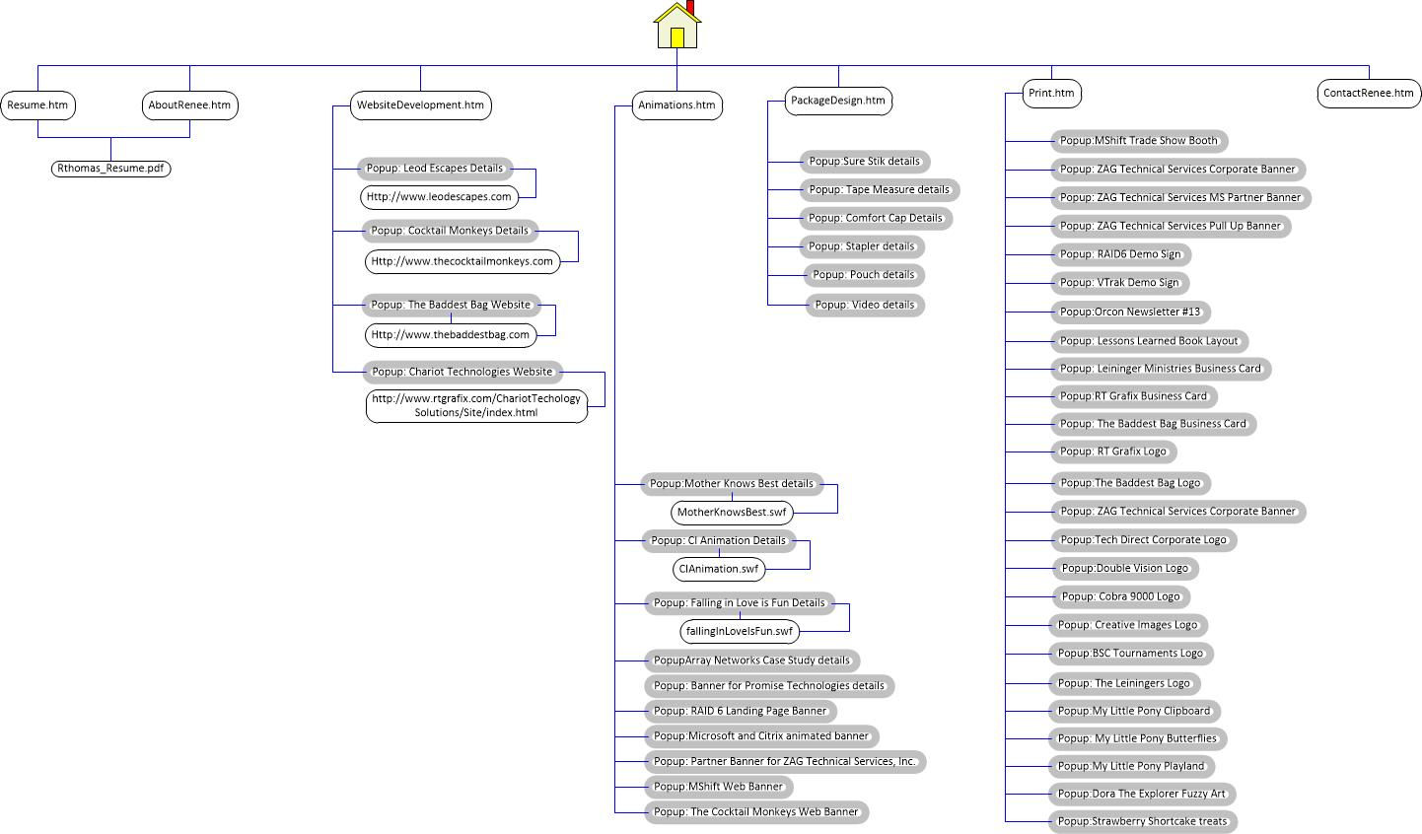 7

Website Title

Renee Thomas Portfolio

Developer’s Name

Renee Thomas

Focus of the Website

My body of work in both Graphic Design and Website Development

Mission Statement

The purpose of the website is showcase pieces of work I have created over the years in order to show future employers my experience in my industry and ability to fit their needs.

Intended Audience

The intended audience will be technology recruiters and their clients looking for Graphic Designers and Web Developers.

Web Pages Definitions

Home

The home page will be a clean, visually oriented page to catch attention. It will most likely only have navigation and images of each of the design categories that are going to be showcased throughout the rest of the site.

Resume

This page will be an HTML version of my resume. Within this page there will also be a “print” link that will take the user to the PDF version of the resume.

About

The About page will tell the user who I am, and will give a history of my experience and education, along with her hobbies and interests. There will also be a link to a PDF version of my resume.

Website Development

This page will show thumbnails of some of the best websites I designed. When you roll over each thumbnail, a popup will explain who the site was created for, and how it was created (the software and type of coding). There will also be a link within the popup to allow you to go to the official site.

Animations

The Animations page will show thumbnails of some of the best animations I designed and created. When you roll over each thumbnail, a popup will explain who the animations were created for, and how they were created (the software and type of coding – if any).

Package Design

This page will show thumbnails of some of the best packages I designed. When you roll over each thumbnail, a popup will explain who they were created for, and how they were created (the software used).

Print

This page will showcase miscellaneous print designs I designed using thumbnails. When you roll over each thumbnail, a popup will explain who they were created for, and how they were created (the software used).

Contact

This page will be a form will be set up to send an email with the user’s comments to me.

Technological issues

This site is going to made of one long page that scrolls to each section when the button for that section is pushed. The scroll will be done using a mix of html5 and CSS3 and jQuery.

On the contact page, security measures will need to be used when including phone numbers and email addresses. The form itself will need to include validation on all of the form inputs.

In the Websites section, the link to the outside site, will need to be set to open in a new link so the user can easily navigate back to the portfolio site.

Design Considerations

The site needs to have clear/ clean navigation. The colors of the site will be mostly black and white like the logo. Color will be brought in via the thumbnails of the different projects. Another thing to consider is typography. What fonts will I use, and should I animate the section titles (using Paralax 3-D style) as the user scrolls to each new section of the page.

Limiting Factors

One of the reasons I decided to go back to school for website development (coding), is because I tend to get stuck on the design factors of a site. I will need to find several sites that I like and want to emulate, and take pieces of each to create my design. The design aspect of the site is what has kept me from updating my portfolio for so long. I come up with designs and then show them to my Graphic Designer friends and they never like my designs and say I’m dated. This has been a huge challenge.

The other big challenge is going to be using HTML5, CSS3, and jQuery. These are the programs I need to showcase to be able to get a higher paying web development position than what I have now. Since this class only teaches HTML4, CSS2 I will have to do lots of extra studying.

Portfolio Site Diagram

